Answers to Review Questions
Chapter 20

1. Two others.
2. Only one.
3. A node that has no children.
4. An entire branch of the tree, from one particular node down.
5. The order in which the values are inserted.
6. Inorder, preorder, and postorder:

Inorder traversal
1. The node’s left subtree is traversed.
2. The node’s data is processed.
3. The node’s right subtree is traversed.
Preorder traversal
1. The node’s data is processed
2. The node’s left subtree is traversed.
3. The node’s right subtree is traversed.
Postorder traversal
1. The node’s left subtree is traversed.
2. The node’s right subtree is traversed.
3. The node’s data is processed.

7. root node
8. children
9. leaf node
10. subtree
11. inorder, preorder, and postorder

12. Create a new node.
Store a value in the new node.
Set the new node's children pointers to NULL.
If the tree is empty
Make root point to the new node.
Else
Starting at the root node, compare the new node's value with
the existing nodes' values. When the new node's value is less
than the existing node's value, go the node's left child for the
next comparison. Otherwise, go to the right.
Repeat this process until a NULL child pointer is found.
That is the insertion point.
End If.

13. (Recursive Function)
Display In Order(Node Pointer)
If Node Pointer is not Null
Display In Order (Node Pointer -> Left).
Display the node's Value.
Display In Order (Node Pointer -> Right).
End If
End Display In Order

14. (Recursive Function)
Display Pre Order(Node Pointer)
If Node Pointer is not Null
Display the node's Value.
Display Pre Order (Node Pointer -> Left).
Display Pre Order (Node Pointer -> Right).
End If
End Display Pre Order

15. (Recursive Function)
Display Post Order(Node Pointer)
If Node Pointer is not Null
Display Post Order (Node Pointer -> Left).
Display Post Order (Node Pointer -> Right).
Display the node's Value.
End If
End Display Post Order

16. Node Pointer = Root.
While Node Pointer is not Null
If Node Pointer -> Value equals the Search Value
Return True. // Item found
Else If the Search Value is less than Node Pointer -> Value
Node Pointer = Node Pointer -> Left.
Else
Node Pointer = Node Pointer -> Right.
End If.
End While.
Return False. // Item not found

17.
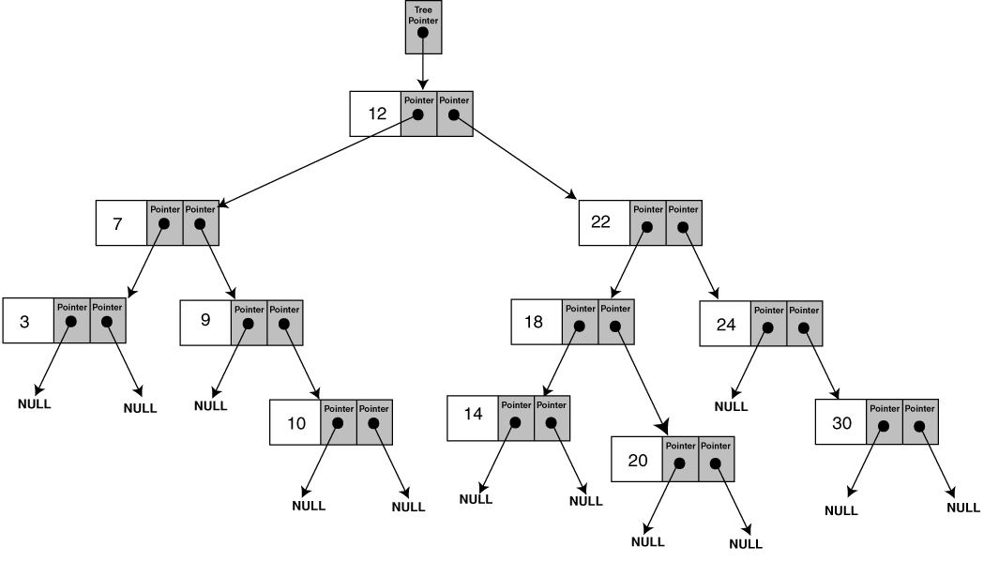

18. 3 7 9 10 12 14 18 20 22 24 30

19. 12 7 3 9 10 22 18 14 20 24 30

20. 3 10 9 7 14 20 18 30 24 22 12

21. true
22. false
23. true
24. true
25. false

